WALES BIODIVERSITY PARTNERSHIP
PRIORITY BAP ACTION AREA MAPPING:
FIRST TRANCHE MAY 2011
NB: This first tranche of Priority BAP Action Area maps has been produced by the;

- Upland Ecosystem Group
- Lowland Grassland and Heathland Ecosystem Group
- Coastal Group
- Enclosed Farmland Group

A number of projects within these groups are in the process of being completed e.g. Hard Cliff, additional farmland birds projects etc. and these will be added shortly.

At present a few LBAP areas have no Priority Actions Areas identified however this is likely to change once the remaining terrestrial Ecosystems Groups complete the prioritization process. The second tranche will cover the priorities of the;

- Woodland Ecosystem Group
- Urban Ecosystem Group
- Wetland Ecosystem Group

Background

During the WBP LBAP seminars in 2009/2010 many LBAP Officers and WBP partner organisations expressed the need for further guidance on priorities for biodiversity action from the Wales-level WBP groups. The current initiative builds on the CCW publication Priority Habitats (2002) but aims to provide more focused national priorities and to display these spatially to reflect the increasing use of Geographical Information Systems for strategic conservation planning.

The Priority Action Mapping exercise is the first phase of this process and aims to provide a strategic view of our biodiversity resource and future goals at a national scale and to coordinate information so that clear priorities for different aspects of biodiversity in different places can be identified.

It is envisaged that the initiative will inform the work of a wide range of bodies including the statutory agencies, WAG, Local authorities, NGOs and the private sector. The initiative will;

- Enable LBAPs and WBP partner organisations to prioritise action focusing on those habitats/species in greatest need of management within each geographical area;
- Help to identify key areas for large-scale projects;
- Provide a focus for drawing down external funding (increasingly grants awarding bodies are keen to know how potential projects match national priorities);
- Allow the WBP Wales-level groups to concentrate on providing specific advice and assistance to LBAPs and WBP partner organizations on areas of national importance.

The exercise does not detract from the work the LBAPs undertake to identify local priorities but helps to set these in a national context. With reduced budgets and fewer staff in both the voluntary and public sectors there will be an increasing need to target resources at the most urgent actions to meet the 2020 national and international biodiversity targets

The Process

This initial exercise was undertaken by the terrestrial Ecosystems Groups utilising the wide experience of group members to identify key geographical priorities based on action needed for both habitats and associated species. The groups considered areas in a national context taking into account the extent, condition, fragmentation and continuing trend of each habitat and the population size, range, isolation and continuing trend of associated species.

The Ecosystem Goups took varying approaches to mapping Priority Areas depending on the habitats and the issues identified. For example in the uplands many of the problem which need addressing occur over large tracts of land much of which is common land where it is difficult to make an impact. Therefore it was argued that small projects within larger sites are needed to act as ‘seeds’ to show that there are problems and demonstrate to surrounding landowners that action is possible and what can be done. Also there is more likelihood of action being undertaken if a project is more tightly defined (particularly in these times of very limited resources) and if biodiversity gain is demonstrated through such projects, then further action is also more likely.

In the lowlands habitats are often small and fragmented, which can make management of individual sites difficult and costly. Therefore some groups looked at a landscape-scale to see how to better manage and connect fragmented sites within larger clusters.

Each Priority BAP Action Areas has been mapped on MapInfo and has an accompanying synopsis which provides back ground information on the habitats and species, identifies the key issues and provides brief information on the action required.

Priority BAP Action Mapping in the Wider Priority Mapping Context

The Priority BAP Action Mapping sits within the context of wider mapping work that CCW is carrying out partly in contribution to the work of the C3 Evidence Workstream of the Natural Environment Framework.

The aim of this work is to;

- Produce a comprehensive set of maps identifying biodiversity priorities at national/regional/local scales (along with metadata to show origin, relationships and application of large-scale datasets);

- Provide guidance on the national and regional/local importance of different habitats and species to enable action to be prioritised and targets to be refined;

- Provide guidance on connectivity for a range of habitats, indicating maps of critical areas to support the core biodiversity sites and overall connectivity at a regional scale.

The mapping is divided into three levels.

Level 1 shows the distribution and area of existing habitats/ecosystems and includes the zone around the habitat that represents their potential functional extent. The potential fnctional extent has been mapped using the least cost modeling approach developed by Forest research and CCW (Watts et al. 2005; Catchpole, 2006; Latham, 2006; Mosely et al., 2008; Watts, et al., 2010).

Level 2 shows the priority areas for targeting action to improve the health and resilience of habitats/ecosystems. This may be through habitat expansion, restoration or improvements to permeability between habitat patches so that ecosystems become more robust and functionally connected. Priority areas are identified by selecting key networks from Level 1 e.g. those networks which support statutory or second tier sites or ket sites for Section 42 species.

Level 3 shows the Priority BAP Action Areas

Level 1
Level 2
Level 3
Resource and connectivity
Priority areas for improving health and resilience
Priority BAP Action Areas

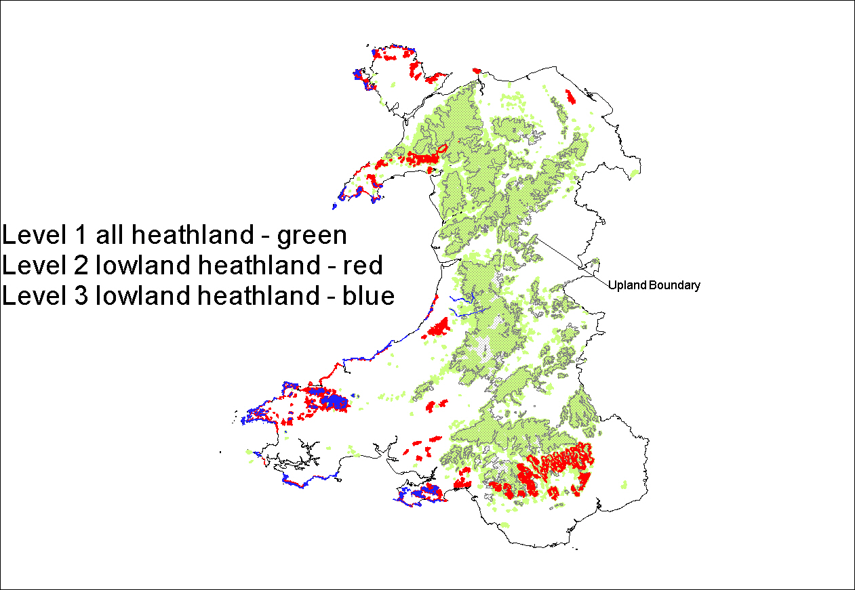
Draft Map for Lowland Heathland
The wider maps and guidance will be used to;

- Provide a strategic view of our biodiversity resource;

- Encourage all organisations to prioritise nature conservation action;

- Focus resources to ensure that they deliver maximum benefit in key areas;

- Develop a consistent mechanism for the delivery of biodiversity information into spatial planning;

- Ensure biodiversity is properly integrated into environmental goods and services work.

References

Catchpole, P. (2006). Planning for Biodiversity – opportunity mapping and habitat networks in practice: a technical guide. English Nature Research Report 687.

Latham, J. (2006). Forest habitat networks for Wales. Quarterly Journal of Forestry, 100 (4): 280-288.

Mosely, D., Ray, D., Watts, K., and Humphrey, J.W. (2008). Forest Habitat Network Scotland. Contract report to Forestry Commission Scotland, Forestry Commission GB and Scottish Natural Heritage. Forest Research.

Watts, K., Griffiths, M., Quine, C., Ray, D. and Humphrey, J. (2005). Towards a Woodland Habitat Network in Wales. CCW Contract Research Report 686.

Watts, K., Eycott, A.E., Handley, P., Ray, D., Humphrey, J.W. and Quine, C.P. (2010). Targeting and evaluating biodiversity conservation action within fragmented landscapes: an approach based on generic focal species and least-cost networks. Landscape Ecology, 25: 1305-1318.

