Environmental Data Sharing Charter

Environmental data is gathered in Wales by a wide range of bodies (including public, private and third sector organisations) and for a wide range of purposes. This Charter aims to ensure that any data collected is shared so that it is used to inform and benefit all parties with an interest in the environment of Wales. The Charter is the embodiment of the aspiration to collect data once, but to use it many times.

Key Principles
Organisations that sign up to this charter agree to the following key principles and adhere to guidance set out by WBP’s Wales Environmental Information Steering Group (WEISG):

- Presumption to share
In this context environmental information will focus on biodiversity but will also include geology, landscape, soils, water & air, historical/cultural, climate, noise, light, flooding, waste, access & recreation. Signatories will agree to share and publish any data that they are permitted to share that fits these criteria. Justification to restrict publishing or sharing should only be where signatories are legally required to restrict access through the Data Protection Act, Copyright or by following WEISG agreed guidance on Environmental Information Regulation restrictions.

- Timely submission of new data & update of published datasets
Signatories will agree to submit data and update published datasets according to the agreed timescales set out in WEISG guidance. The guidance will be developed to account for the needs of each sector or partner and in the context of end user requirements. Timely submission and dissemination of data facilitates the implementation of the “collect once use many times” principle and allows decisions to be based on recent (or current) data.

- Submit data once to single appropriate custodian
Data providers who sign up to this agreement agree to only submit data once to a single agreed data custodian. This will help avoid data duplication and duplication of effort. A single custodian also gives users the confidence that they are accessing the correct and latest version of a dataset. The data custodian will then maintain and disseminate their collated records and datasets on behalf of the provider according to WEISG standards and practices.

- Adopt agreed model for data flow
Signatories agree to follow the data flow models that will be agreed by WEISG for specific data types. This will help avoid data duplication and duplication of effort. Agreed mechanisms and initiatives for sharing and publishing data types will be issued as WEISG guidance and updated as the charter is implemented.

- Acknowledge the source
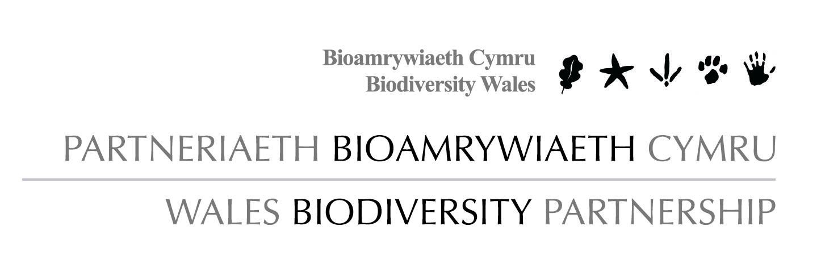Signatories will always acknowledge the source of the recorder or the custodian of a dataset when publishing or sharing environmental data. Acknowledgement recognises the contribution of collector and custodian and helps the recipient to validate the data they receive.

- Users able to access all data through agreed routes
Datasets will be shared between all relevant and approved initiatives or mechanisms from master copies. This will enable users to access all relevant data through any one of the WEISG recommended initiatives or mechanisms as detailed in WEISG guidance.

Environmental Data Sharing Charter
Annex 1: Developing Agreements Between Signatories to the Charter

The Charter has been drafted as a set of high level principles that the signatories will adhere to however, for the process to effectively free up data in the way that the Wales Environmental Information Forum (WEIF) intended, there will need to be a more detailed document setting out a clear framework of behaviors and practices that underpins the higher level documents.

It is proposed that this could be achieved through a Memorandum of Understanding (MoU) or similar agreement setting out the ground rules or a suite of WEISG guidance.

The MoU or guidance will therefore need to address the following issues:

- Need for a single master dataset and a way of identifying who holds and maintains it.

- Need to define the level of detail at which data is shared.

- Need to define the level of detail at which data is captured (set a minimum level)

- Roles and responsibilities in respect of data flow and management (from point of collection to point of use)

- Data completeness and accuracy (defining what signatories’ agree to be a complete data entry)

- Methods of acknowledging the source and recording this (i.e. through metadata)

- Clarity about permissions

- The MoU will need to clearly define the role of the data custodian and approved practices within the framework that is being developed (for example data quality, provision of metadata, procedure for restricting access).

- Approved initiatives and mechanisms. Data Custodians will share biodiversity datasets through the National Biodiversity Network (NBN) Gateway, Local Records Centres and National Schemes and Societies as a minimum. Marine data will be shared and published through the UK Marine Environmental Data and Information Network (MEDIN).

- Clarity about timely submission and update: The needs of end users and the needs of the data providers will need to be matched in agreeing the appropriate timescale for each sector or organization. E.g. public, private and academic data providers may need to implement different timescales for publishing.

Annex 2: Definition of technical terms or points to be clarified

- Sharing with a single custodian: Data flow should produce a single master version of a record. To avoid duplication of a record, any record should be submitted once, to one location (individual or organization) who will act as a custodian responsible for maintaining the record and for sharing the complete record with all other elements of the agreed data flow model. For biodiversity records, a custodian could be any one of the following: LRC, NSS, Government body. Actual custodians will be defined for each data type in the detail of the supporting Memorandum of Understanding (MOU) or similar agreement.

- Timeliness: In order to maximize use and enable reference to current records, data flow should process records as close to the time and place of observation as possible. The exact detail of what timescale will be used will be agreed for each data type or data provider. This will be defined in the underlying memorandum of agreement. Ideally records would be submitted in a timescale that maximizes benefit to nature, is appropriate for the end users and does not invalidate academic research.

