Wales Coastal Ecosystem Group – notes of fifth meeting, 1st June 2011, CCW Aberystwyth

Present: Peter Rhind Chair of CEG (CCW), Quentin Grimley (CCW); Matty Murphy (CCW); Duncan Ludlow (CCW), Kate Collins (EA)

Telephoned: Chris Wynne North Wales Wildlife Trust (WTW), Richard Ellis (NT)

Apologies: Sean McHugh (WBP), Mark Winder (City and County of Swansea); Nicola Rimington (CCW); Kerry Seaton (CCW); Hilary Foster (EA); Kate Williamson (NPA); Mike Howe (CCW);Beth Henshall (WEL);Mike Howe (CCW); Steve Chambers (WG); Angus Garbutt (CEH); Mike Bailey (CCW)

Unfortunately due to low attendence (mainly CCW staff) the agenda was curtailed to just the main agenda item (Biodiversity Mapping), but because this involved the use of graphics it was deemed unsuitable for people on telephone. Another important agenda item item was CCW’s Sand Dune Re-Mobilisation Workshop planned for September of this year (see below).

Coastal BioDiversity Mapping
Peter Rhind gave a short presentation on coastal biodiversity mapping. This is part of a wider exercise to map priority biodiversity areas as part of the Natural Environmental Framework (NEF) and provide a basis for management and resource planning.

In the presentation Peter described how MapInfo has been used to compile biodiversity priority maps for sand dunes, saltmarsh, soft sea cliffs, hard sea cliffs and vegetated shingle, and each of these is now accompanied by a written synopsis. The example below is the priority map for sand dunes.

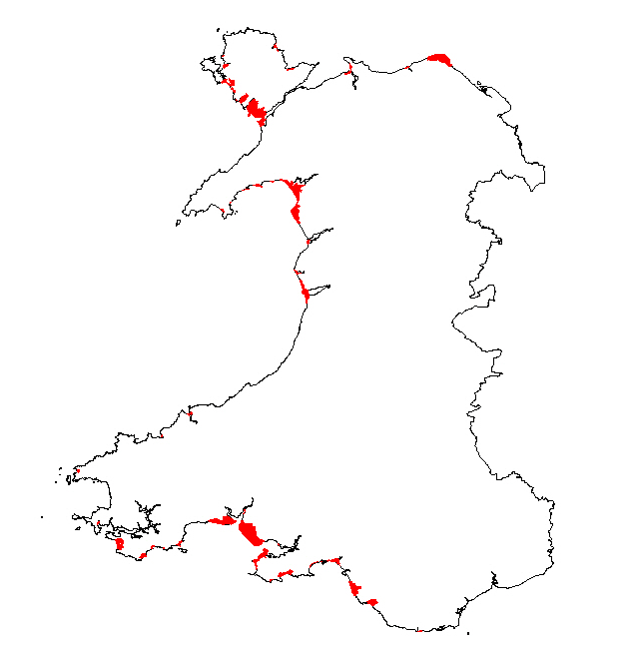

The Priority Action Mapping exercise is the first phase of this process and aims to provide a strategic view of our biodiversity resource and future goals at a national scale and to coordinate information so that clear priorities for different aspects of biodiversity in different places can be identified.

It is envisaged that the initiative will inform the work of a wide range of bodies including the statutory agencies, WAG, Local authorities, NGOs and the private sector. The initiative will;

1. Enable LBAPs and WBP partner organisations to prioritise action focusing on those habitats/species in greatest need of management within each geographical area;

2. Help to identify key areas for large-scale projects;

3. Provide a focus for drawing down external funding (increasingly grants awarding bodies are keen to know how potential projects match national priorities);

- Allow the WBP Wales-level groups to concentrate on providing specific advice and assistance to LBAPs and WBP partner organizations on areas of national importance.

Jan Sherry & Jim Latham will be presenting the latest update from the priority habitat mapping exercise at the WBP Biodiversity Conference in Carmarthen on 14th September.

Sand Dune Re-mobilisation Workshop
Most of the Natura 2000 sand dunes features in Wales are now considered to be unfavourable and declining. The dune resource of Wales has changed dramatically over the past 50 years. It has become much more stable with far fewer mobile dunes and embryonic dune slacks. At Newborough Warren, for example, nearly 75% of the total dune area in the 1950s consisted of mobile dunes and embryonic dune slacks with open vegetation. By 1991 only about 6% of the site could be classed as mobile and open, while embryonic dune slacks are now virtually non-existent. Of the total Welsh dune resource of about 8051ha, only about 135ha can be described as bare or sparsely-vegetated. Many of our rarest dune plants are confined to these habitats and there are now major concerns over the long-term survival of the now critically endangered fen orchid (Liparis loeselii var. ovata). This species has a requirement for early successional dune slacks and is now confined to just a handful of dune slacks in South Wales. In addition, recent analysis has identified 131 species of invertebrates restricted to sand dunes in Wales, of which 54 (41%) are associated with bare or sparsely-vegetated sand. A total of 278 species of aculeate bees, wasps and ants have been recorded from Welsh dunes, 68% of the known Welsh fauna, including 16 species found only on dunes of which 13 are associated with open sand. Factors considered to have influenced stabilization include the deposition of atmospheric nutrients, soil development and a decreasing sediment supply. Climate change is also likely to become a major influence. Internal factors such as levels of managed grazing can also be influential, but there are now concerns that the degree of stabilization has gone beyond normal management control for many sites and we may now be facing accelerated levels of ecological succession.

A number of techniques to counter stabilization are now being trialed in Wales. These include topsoil stripping and deep-ploughing (top-soil inversion). However, to successfully reverse this trend we need to consider reasonably large-scale destabilization on several targeted sites. This would go some way towards achieving favourable condition on these sites.

Way forward
There are some understandable reservations about re-mobilisation and one of the aims of the workshop will be to try and alleviate some of these concerns and to try and develop a programme of dune re-mobilization in partnership with key stakeholders. There is little doubt that we will need to take some hard decisions or could be facing even harsher criticism if we start to witness the local extinction of dune species. A programme of re-mobilization is now listed as a priority in the Coastal Ecosystem Group Action Plan developed under the auspices of the Wales Biodiversity Partnership. However, this is not just a CCW or a Welsh issue. The concept of remobilsation is of considerable interest to Natural England and Scottish Natural Heritage. Natural England, for example, is planning to implement the Common Standards Monitoring requirement to create 10% bare sand on each of its key sites. There is also the Natural Environment and Rural Communities Act (NERC) requirement for all public bodies to have regard for conserving biodiversity.

Sand dune mobility is not just about maintaining habitats and species. Most people would agree that dune landscapes devoid of bare sand are far less aesthetically appealing than active, dynamic systems. Most people that visit sand dunes expect to see open sandy areas. Dune stabilization may therefore have a detrimental effect on the coastal landscapes of Wales, which in turn could have implications for the tourism and the holiday industry.

Sand dunes are also an important educational resource with many schools and universities using them to carry out ecological studies. They are particularly important for demonstrating zonation and natural succession, but further stabilization would significantly degrade their value in this respect.

