Noctule bat Nyctalus noctula
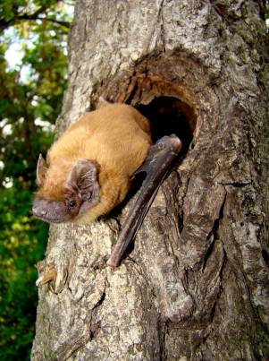

Background
The noctule bat is one of the largest British bats. They are primarily tree dwellers and live mainly in rot holes and woodpecker holes. They rarely occur in buildings.

Noctules hibernate mainly in trees or rock fissures and hollows, but have also been found in bat boxes, buildings
and other man-made structures in winter.

Maternity colonies frequently change roosts.

Most food is caught on the wing and eaten in flight but occasionally prey is taken from the ground.
Photo: Martin Celluch
© Bat Conservation Trust
In suburban areas noctules are attracted to street lamps
to feed on moths. During spring noctules will feed mainly
on smaller insects such as midges, changing their diet to take beetles (mainly chafer and dung beetles), mayflies, winged ants and moths later in the season.

They are known to fly over 10km from roost to feeding areas.

Status in Wales
Range | Insufficient information to determine status or distribution but it is probably widespread but in low numbers across lowland Wales
Population | estimated numbers:  4750 in Wales (http://www.jncc.gov.uk/_speciespages/2459.pdf)  50,000 in UK (http://www.jncc.gov.uk/_speciespages/2459.pdf)
Threats
(taken from http://www.jncc.gov.uk/pdf/Article17/FCS2007-S1312-Final.pdf)
- Habitat loss/degradation:
Felling / loss of trees
Loss of hedgerows and copses
Modification of agricultural practices including use of pesticides and abandonment of pastoral systems
Agricultural enrichment
Pollution of freshwater
Infilling of water bodies
Infrastructure
- Human Disturbance:
Interference / displacement
- Recreation and tourism

Status
Wildlife & Countryside Act 1981(as amended), Schedule 5
The Conservation of Habitats and Species Regulations 2010, Schedule II
Natural Environment and Rural Communities Act 2006, s42
EC Habitats & Species Directive, Annex IV
Bern Convention, Appendix 2
Bonn Convention, Appendix 2
BAP
UK Biodiversity Action Plan
Species of principal importance for the conservation of biological diversity in Wales

Lead Partner – Bat Conservation Trust (www.bats.org.uk)

Draft Wales BAP targets
No numeric target has been set for this new BAP species. Targets to be reviewed in 2011.
Although this species is probably widespread across lowland Wales, there is insufficient information to determine the true status or distribution in Wales. Further in information is required to determine the range and distribution of the noctule bat and set numeric targets.

Code | Target type | Target | Units | 2005 | 2010 | 2015 | 2020 | 2025
NnoT1 | Range | Establish a baseline distribution | Occupied 10 Km squares

Actions
The following actions do not include statutory obligations with respect to species legislation, and investigation and enforcement measures of potential wildlife offences.

As a European Protected Species under the Regulation 9(5) Conservation of Habitats and Species Regulations 2010, a competent authority, must have regard to the requirements of the Habitats Directive in exercising any of their functions, so far as they may be affected by the exercise of those functions. This means that where a EPS is/or likely to be affected, then it will need to take account of the provisions provided by the Regulations.

Code | Action Type | Action | Action Lead | Ecosystem Groups | Delivery Agents
NnoA1 | Survey and Monitoring | 1. Continue population monitoring within the National Bat Monitoring Programme.  2. Encourage and support distribution surveys to locate further populations and improve knowledge of distribution. | BCT (Steve Lucas) |  | BCT  LBAPs  VWT
NnoA2 | Research | Support and encourage research to improve understanding of this species.  Undertake research on the potential impact of wind farms on this species within the UK | BCT (Steve Lucas) |  | BCT  NRW  Defra
NnoA3 | Habitat and Site Management | Manage woodland, parkland, amenity trees and farmland to maintain and increase the number of suitable roosting places for noctules and maintain and increase foraging habitat. Promote best practice to ensure that the roosts are protected from avoidable loss (e.g. felling prior to development or for Health & Safety reasons. | BCT (Steve Lucas) | Woodland  Lowland farmland | LBAPs  NRW  Woodland Trust
NnoA4 | Policy and Legislation | No action currently needed
NnoA5 | Communication and Advisory | Produce guidelines for Ecosystem Groups on appropriate habitat management for noctules. | BCT (Steve Lucas) | Woodland | BCT

Implementation issues (and consideration of NEF principles)
Encourage/train volunteers to survey for noctules, encourage bat groups, LBAPs, other relevant organisations esp. local authorities to undertake targeted surveys, encourage AES/WGS owners
Ensure woodland habitat management for condition is appropriate to the needs of this species (continuous cover canopy and well developed under storey, retention of old trees with woodpecker and rot holes). This is vital to ensure this species has sufficient roosting and foraging habitat to sustain and preferably expand its populations. (This could also benefit other bat species).
Research potential impacts form wind turbines

LBAP areas where action is required (shaded yellow)

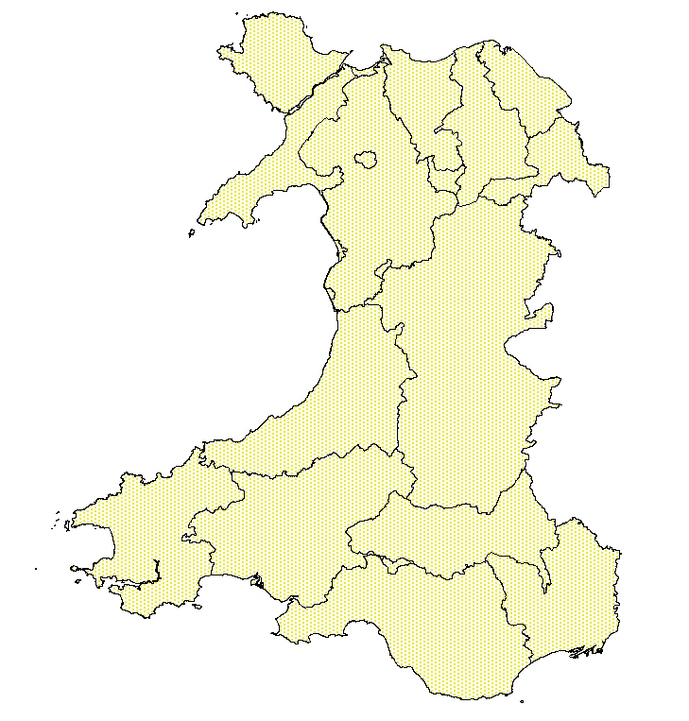

References/Links/Further Information
http://www.jncc.gov.uk/_speciespages/2459.pdf
http://www.jncc.gov.uk/page-4063
http://www.bats.org.uk/publications_download.php/217/noctule.pdf

