Barbastelle bat Barbastella barbastellus

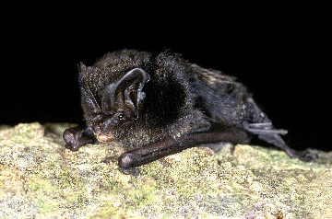
Background
Photo Hugh Clarke © Bat Conservation Trust
Being one of the rarest mammals, much remains to be learned about this bat. In mainland Europe nursery colonies have been found in building crevices but in Wales roosts have also been located in cracks in trees.

The majority of UK winter records are of single bats in underground sites. They are relatively tolerant of the cold, and can be found in caves, tunnels, cellars and trees - sometimes behind loose bark on dead trees. Movement between winter roosts occurs frequently and they have been known to fly and forage in mild spells all winter.

They are specialist foragers in a range of habitats but may forage in quite open areas taking small moths, some flies and beetles.

Status in Wales
Range | Barbastelle is found mainly in southern half of Wales. Breeding roosts have been identified in Ceredigion and Pembrokeshire although there are additional records from Snowdonia, Powys, and Neath.
Population | estimated numbers  500 in Wales (http:// www.bio.bri.ac (2005))  5000 in UK (http://www.jncc.gov.uk/_speciespages/133.pdf)

Threats
(taken from http://www.jncc.gov.uk/page-5170 2007)
- Global warming
- Habitat loss/degradation:
Felling / loss of trees (general)
Felling / loss of trees (specific host trees / ancient trees)
Inappropriate timing of forestry rotation
Lack of dead wood
Agricultural enrichment
Pollution of freshwater
Infrastructure
Infilling of ditches, dykes, ponds, pools, marshes or pits;
Inappropriate water channel / river bank management
- Human Disturbance:
Interference / displacement
Recreation and tourism

Status
Wildlife & Countryside Act 1981(as amended), Schedule 5
The Conservation of Habitats and Species Regulations 2010, Schedule II
Natural Environment and Rural Communities Act 2006, s42
EC Habitats & Species Directive, Annex II & IV
Bern Convention, Appendix 2
Bonn Convention, Appendix 2

BAP
UK Biodiversity Action Plan
Species of principal importance for the conservation of biological diversity in Wales

Lead Partner – Bat Conservation Trust (www.bats.org.uk)

Wales BAP targets
(set in 2009)

Code | Target type | Target | Units | 2005* | 2010 | 2015 | 2020 | 2025
BbT1 | Range | Maintain the current range of Barbastelle bats in Wales  (13 10 Km squares) | Occupied 10 Km squares |  | 13 | 13 | 13 | 13
* baseline

The target is to maintain the current range of 10 Km squares occupied by barbastelle bat in Wales (13) but is under review pending further survey work, or occupied by breeding barbastelle bats in Wales (4). At the moment, not enough is known about either the distribution or abundance of this species to enable targets to be set in the longer term for either range expansion or population growth. The baseline will be reassessed to take account of new survey information.

Actions
The following actions do not include statutory obligations with respect to species legislation, and investigation and enforcement measures of potential wildlife offences.

As a European Protected Species under the Regulation 9(5) Conservation of Habitats and Species Regulations 2010, a competent authority, must have regard to the requirements of the Habitats Directive in exercising any of their functions, so far as they may be affected by the exercise of those functions. This means that where a EPS is/or likely to be affected, then it will need to take account of the provisions provided by the Regulations.

Code | Action Type | Action | Action Lead | Ecosystem Groups | Delivery Agents
BbA1 | Survey and Monitoring | 1. Encourage and support distribution surveys to locate further populations and improve knowledge of distribution.  2. Continue population monitoring within the National Bat Monitoring Programme. | BCT (Steve Lucas) |  | BCT  NRW  LBAPs
BbA2 | Research | Support and encourage applied research to improve understanding of barbastelle ecology. Topics include landscape use, roost selection and use, diet and foraging behaviour. | NRW (Jean Matthews) |  | BCT  NRW
BbA3 | Habitat and Site Management | 1. Ensure woodland where barbastelles are present is retained and managed to maintain and develop features important to the species.  2. Encourage appropriate management of woodland within the species' range.  3. Support and encourage appropriate woodland expansion around woodland where barbastelles are present (including young woodland).  4. Encourage and support enhanced connectivity of woodland used by barbastelles. | Woodland ecosystem group | Woodland | LBAPs  Woodland Trust  NRW
BbA4 | Habitat and Site Management | 1. Ensure agri-environment prescriptions are available that support and encourage the development and maintenance of features helpful to barbastelles. 2. Promote the uptake of appropriate agri-environment scheme prescriptions in areas known to have barbastelle populations. | WAG | NRW | WAG  NRW
BbA5 | Habitat creation / restoration | No action currently identified
BbA6 | Communication and Advisory | Produce guidelines for Woodland Ecosystem Group on appropriate habitat management for barbastelles | BCT (Steve Lucas) |  | BCT  NRW

Implementation issues (and consideration of NEF principles)
- Protect the condition of priority woodland and wetland habitat (to help provide sufficient good quality roost trees allied with insect rich foraging grounds). (This could also benefit other bat species e.g. Bechstein’s).
- Encourage woodland expansion to help buffer core woodland areas. Increase flight-line connectivity of woodland areas to each other and to other foraging habitats at the landscape level (e.g. via hedgerow creation). This would help multiple species with dispersion, adaptation (not just bats).
- Encourage bat groups, Woodland Trust, LBAPs, other relevant organisations such as local authority country park staff to undertake targeted surveys in appropriate habitats

Priority LBAP areas where action is required

Red = site protection and management and further survey,
Yellow = survey required

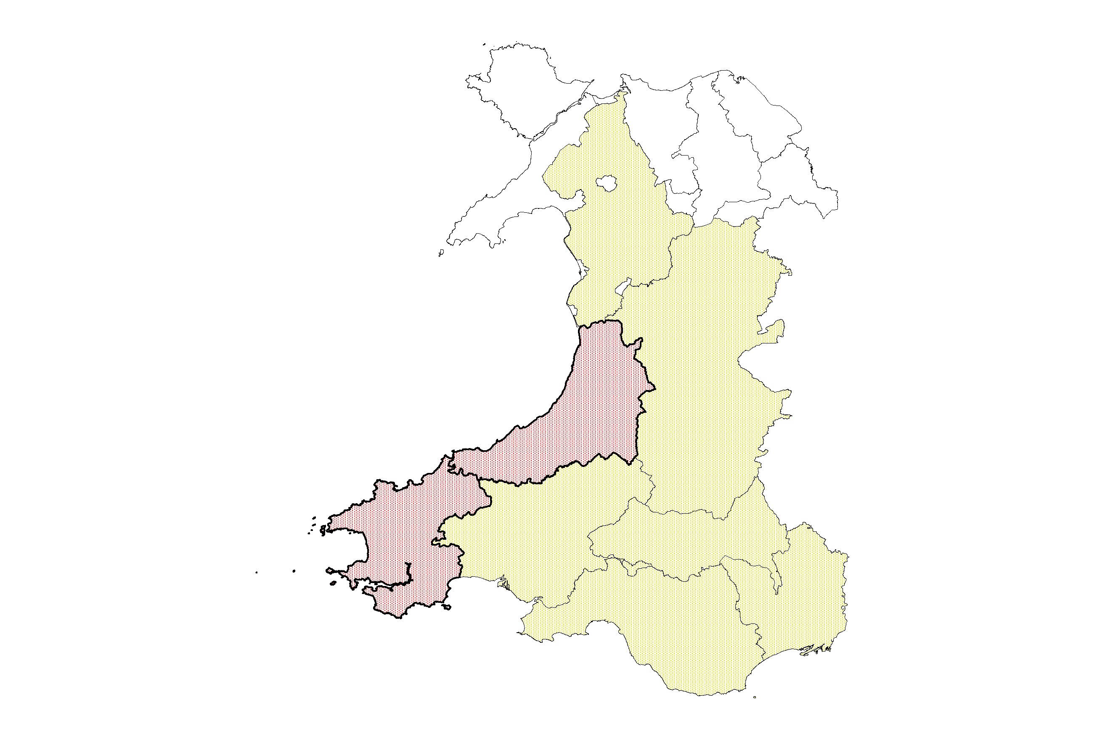

References/Links/Further Information

http://www.jncc.gov.uk/_speciespages/133.pdf
http://www.jncc.gov.uk/page-4063
http://www.ukbap.org.uk
http://www.bio.bris.ac.uk/research/bats/britishbats/index.htm
http://www.bats.org.uk/publications_download.php/747/barbastelle.pdf

