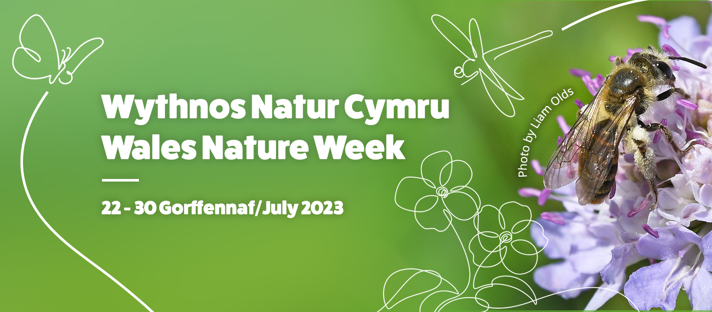

LOCAL PRESS RELEASE

[Your Locality] CELEBRATES WALES NATURE WEEK 2023

*choose the most appropriate option*

Option 1 Wales Nature Week 2023 is being celebrated in [locality] with a [name and locale of event(s)] organised by [name of your organisation] on [date(s)].

The [event(s)] is one of many nature walks, talks and activity days taking place throughout Wales, organised by a range of organisations and individuals coming together for Wales Nature Week. Running between 22-30 July, the theme of this year's Wales Nature Week is ‘Celebrating Nature’s Treasures’.
Participation is easy, and the majority of the events are free. With a range of events to choose from, there’s something suitable for complete beginners to the more seasoned nature lover.
If you can’t attend an event, don’t worry. Simply get out and enjoy nature on your doorstep!

Option 2 Wales Nature Week 2023 is being celebrated in [locality]

Wales Nature Week features nature walks, talks and activity days taking place throughout Wales, organised by a range of organisations and individuals coming together for Wales Nature Week. Running between 22-30 July, the theme of this year's Wales Nature Week is ‘Celebrating Nature’s Treasures.’

Participation is easy, and the majority of the events are free. With a range of events to choose from, there’s something suitable for complete beginners to the more seasoned nature lover.

If you can’t attend an event, don’t worry. Simply get out and enjoy nature on your doorstep!

Sean McHugh of Wales Biodiversity Partnership said: “Every year we choose a theme and this year we are encouraging people to discover the fantastic species and habitats in Wales under our theme: Celebrating Nature’s Treasures.
We cherish and rejoice in the wonder of the natural world, from the seemingly humble to the truly expansive; from the iridescent beauty of a starling’s plumage; taking in the majesty of the Welsh landscape or enjoying nature in the local park.
Large and small, these are our treasures, our natural heritage, inherited by each generation to discover, and it is vital that we celebrate and protect nature now and, in the future”.

For more details about Wales Nature Week 2023 and the calendar of events visit: www.biodiversitywales.org.uk/wales-Nature-week

NOTES TO EDITORS

1. Wales Nature Week is coordinated by Wales Biodiversity Partnership. Wales Biodiversity Partnership brings together key players from the public, private and voluntary sectors to promote and monitor biodiversity and ecosystem action in Wales. WBP is funded by Welsh Government and hosted by Natural Resources Wales.

-END-
ISSUED BY:
[Your contact information]

